**ANSIBLE REFACTORING, ASSIGNMENT, AND IMPORTS**

In this project, we would be working with the ansible-config-mgt repository and making some refactoring on our existing code, creating assignments and also implement the usage of the import functionality. The main aim of this is to make our playbook efficient re-usable, concise and very organise while carry out their tasks.

Code refactoring is often used in the software development because as we constantly change the behaviour of an application by adding new features, we expect to be changing source codes while expecting a particular behaviour. Refactoring enhances code readability, maintainability, reducing complexity for future adjustments with affecting the logic of the application .

Pre-requisite for the projects is the following.

1. Fundamental Knowledge of Installing and downloading software
2. Basic Understanding of Linux Commands
3. AWS account login with EC2 instances
4. 2 UAT Webserver Red Hat Enterprise Linux 9
5. 3 Webservers Ubuntu
6. Database Server: On Ubuntu 22.04+ MySQL
7. Playbooks
8. NFS Storage Server
9. Load Balancer Server
10. Ansible Jenkins Server
11. Jenkins
12. Python Language
13. Code Repository
14. Internet connection
15. Visual Studio Code

IMPLEMENTATION STEPS: Set up of all EC-2 instances.

1. Ensure you login with your details to your AWS console via the <https://aws.amazon.com>
2. Click on the EC2 link and start all 7 EC2 instances and create 2 UAT server instance making sure they are set up with the operating systems below.

i)1 NFS server (Red hat) ii) 3 webservers. iii) 1 Ansible-Jenkins Server

iv)1 Load Balance Server v)1 Database Server vi) 2 new UAT servers as shown below.

We created our 2 UAT servers as seen below.

Type in the name and additional tag to the project (UAT -SERVERS). Select ubuntu from the quick start option .Also note that the Amazon machine image selection varies from user to user

Select RHEL 9 (Free Tier )

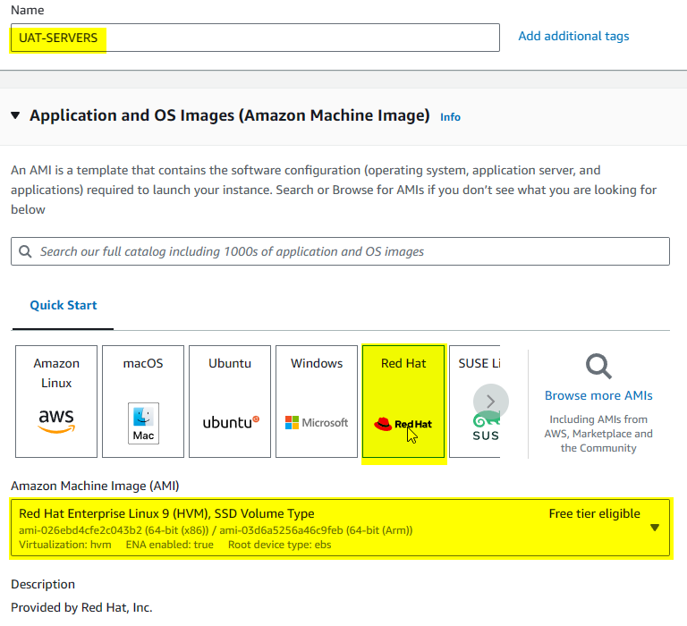

The instance type selected in the configuration is the t2 micro -free tier.

Click on the “Create new key pair” link and Ensure the Checkbox remains unchanged on the “Create security group”.

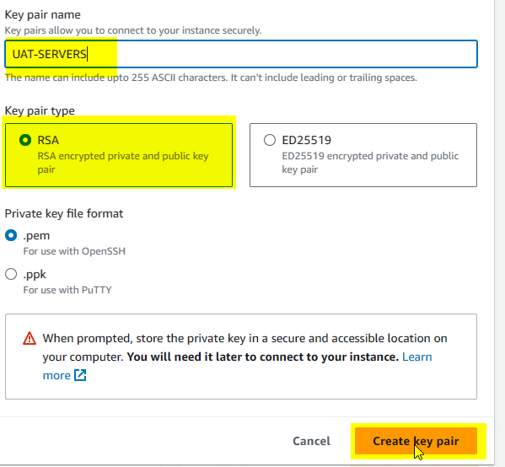

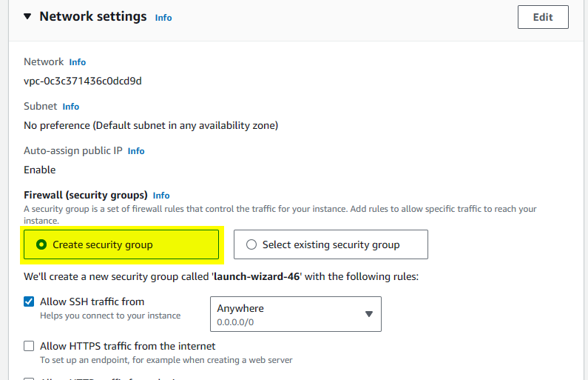

Then we proceed to launch our instance finally.

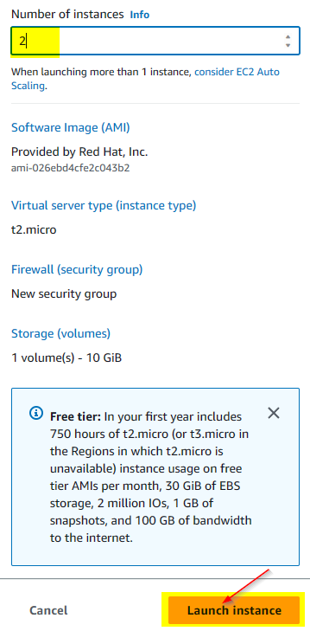

Instance successfully launched and click to view Instance details with the IP address.



We then proceed to enhance our Jenkins job by creating a new directory called ansible-config-artifact as seen below



Once directory is changed, we would need permissions so that Jenkins can save files in the new directory.



Once that is done, we would go to the Jenkins console and download a copy artifact plug-in and check the installed plug-in section to confirm it was downloaded successfully.

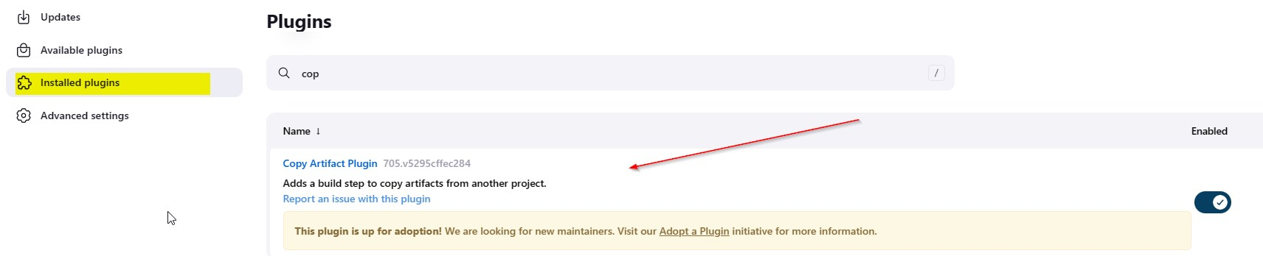

A new freestyle project was created named save_artifacts and this project would be triggered by the completion of our existing ansible new project. We choose the Log rotation strategy and make sure the maximum of build be 3 as shown below

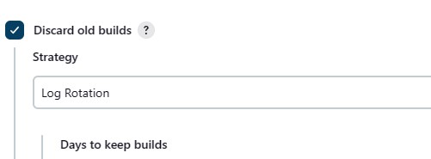

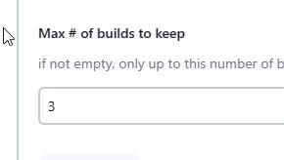

Project to watch out for is the ansible new.

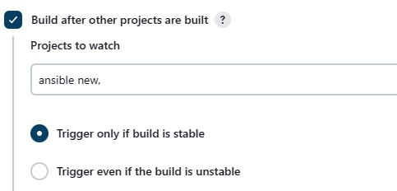

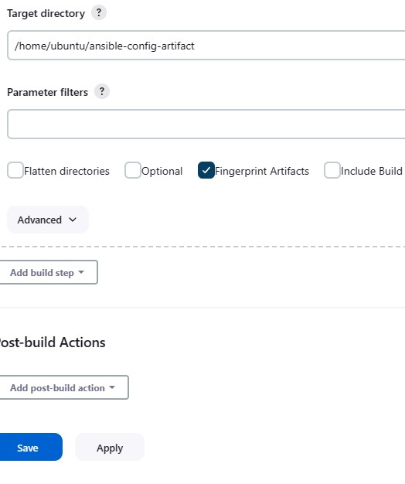

The save artifact project would be saving the artifacts in the ansible-config-artifact directory as seen above. We can test out set up by making some change in the READ.md file.

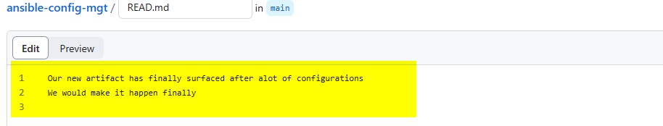 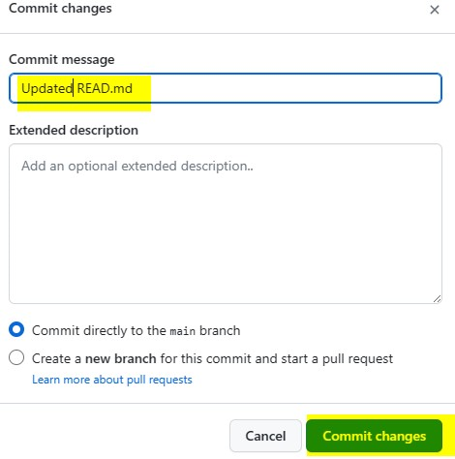

Once done we expect a automatic trigger in our Jenkins pipeline

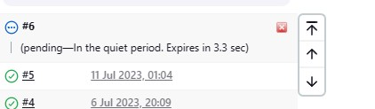

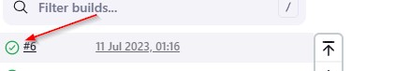

We can now check the console output as well as checking the Jenkins-Ansible server

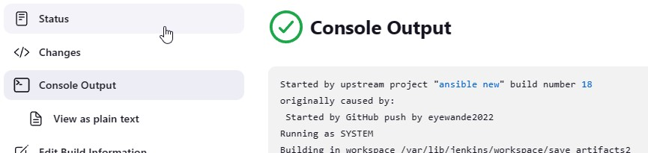

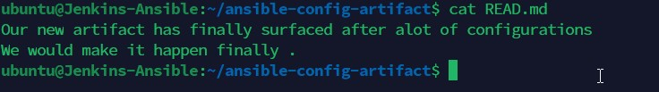

Once this is done, we can now proceed to refactor ansible code by importing other playbooks into the site.yml file

. It is important for us to pull down all latest code from our (main branch) before creating a new branch called refactor.

Once that is done, we can proceed to import other playbooks in our site.yml file which is the entry point into the entire infrastructure configuration. The site.yml file becomes the parent all other playbooks developed.

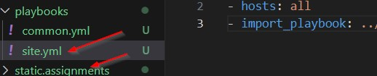

We also have to create a new folder called static assignments where all other children playbooks will be stored. Hence we would be moving the common.yml file we used previously into the static-assignments folder.

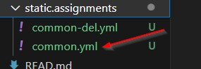

As seen below we imported the common-del.yml file to the site.yml file.

After all necessary folders has been created, we have a folder structure as shown below.

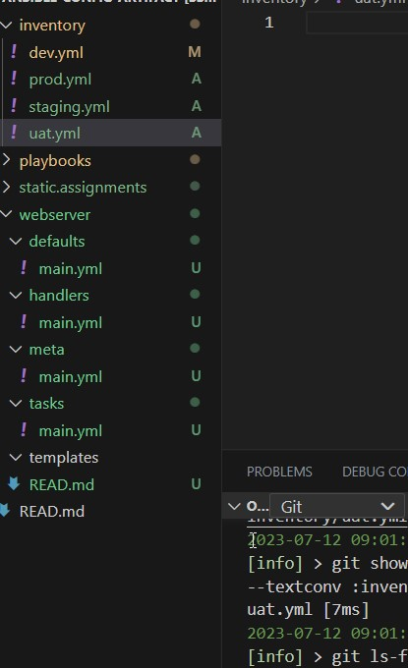

Ensure to run the ansible-playbook command against the dev environment as shown below

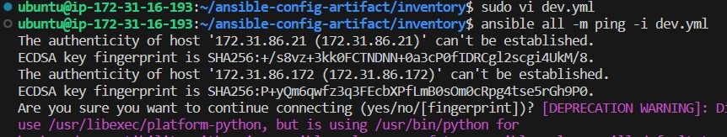

We can see that the private Ip of all servers indicate that they are a success. Please note that wireshark was successful installed on all servers in the previous project

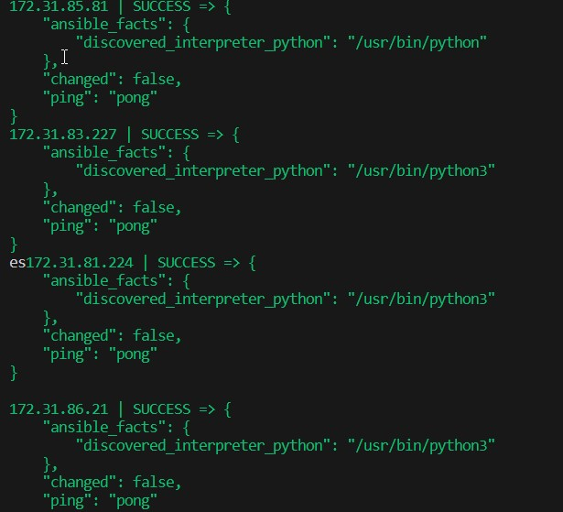

Our new task is for us to create another playbook under static-assignment and name it common-del.yml.The function of the playbook is to delete the wireshark utility on all servers . We are now required to update the site.yml file as shown below

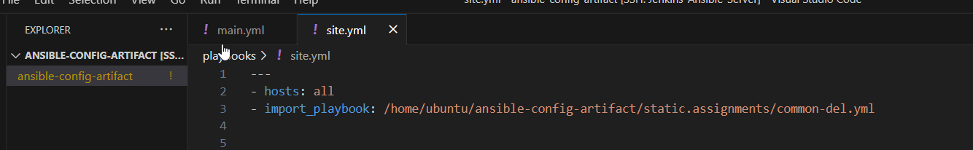

We are now supposed to run the dev.yml file against the site.yml file as show below

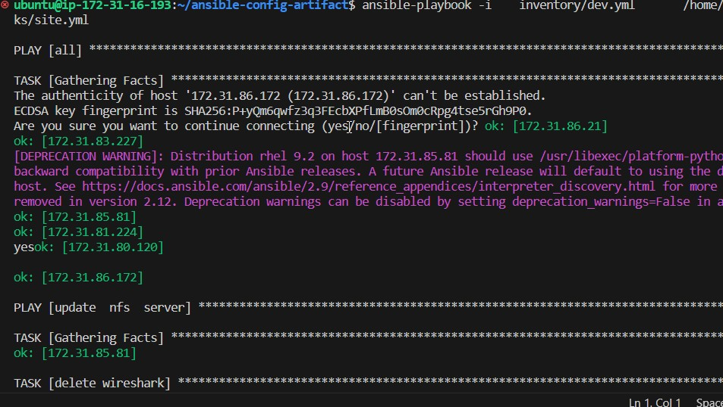

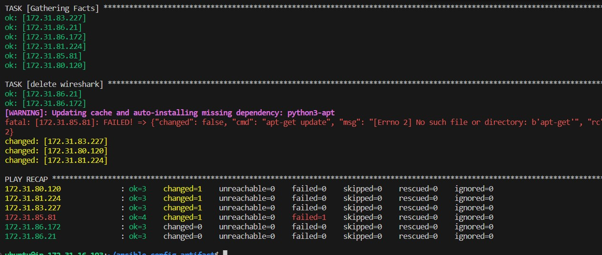

As seen from above the task states that they were deleted but we must confirm this individually.

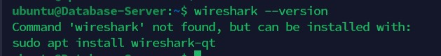



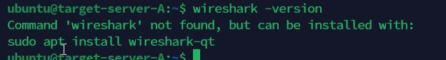

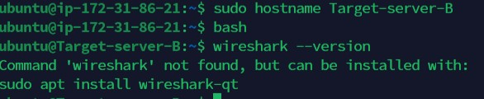

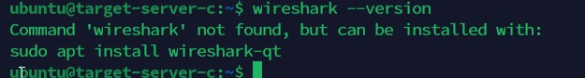

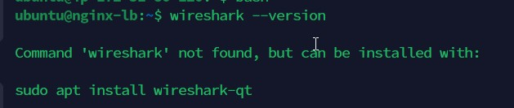

All has been deleted successfully and we have simple learn how to use import-playbooks module and we have a ready solution to install and delete packages on multiple servers by just running one command.

Please note it is encouraged to turn off all other servers that we aren’t using now and only focus on the 2 webservers as the focus.

**CONFIGURATION OF 2 UAT WEBSERVERSWITH A ROLE WEBSERVER**

Having created out UAT webservers earlier we would be creating role.

And a new directory in the /etc/ansible directory as shown below.

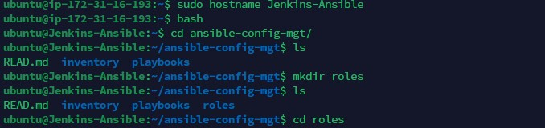

Next would be to initialize our ansible utility called ansible galaxy inside the ansible-config-mgt/roles directory and once completed we are expected to install tree to see the structure of all the files created.

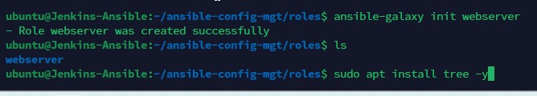

Here are the structure of the webserver and after some modification.

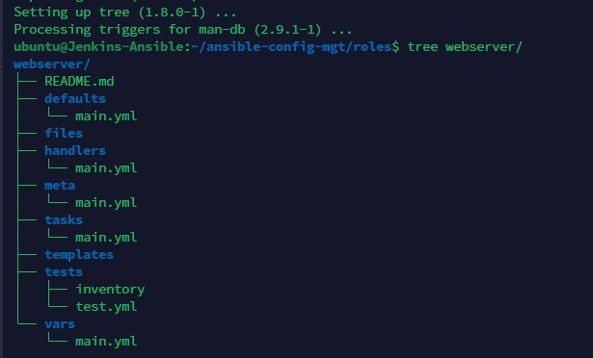

Remove unnecessary folders are as show below

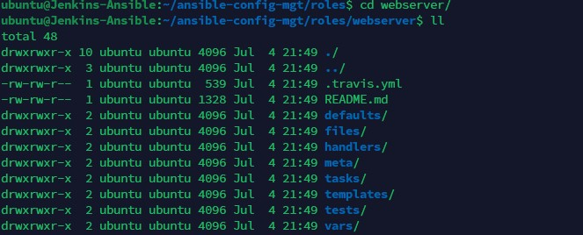

Next step would be to update the UAT.yml file in the inventory directory with the private Ip addresses of the 2 UAT webservers.

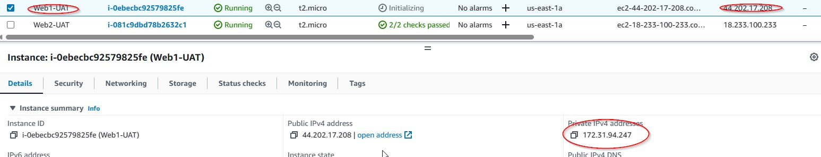

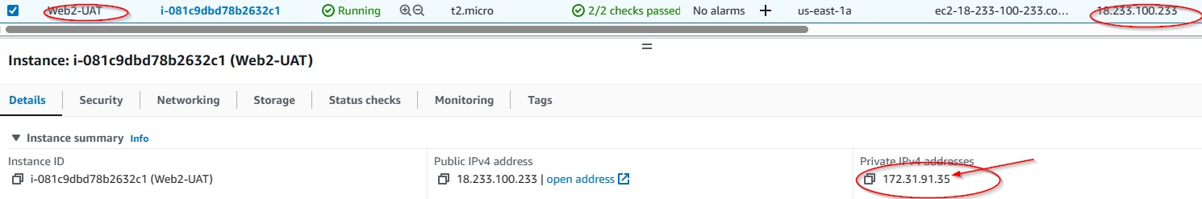

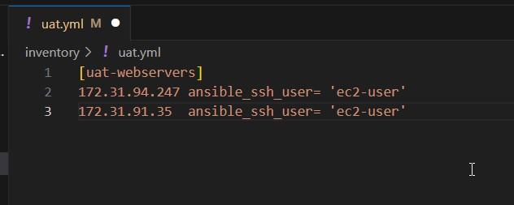

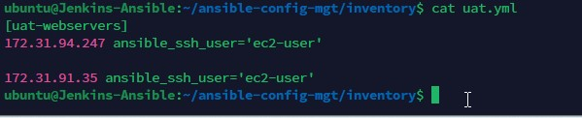

Once this is done, Open the terminal for the 2 UAT webservers and SSH into each public Ip address from the Jenkins-Ansible server as shown below

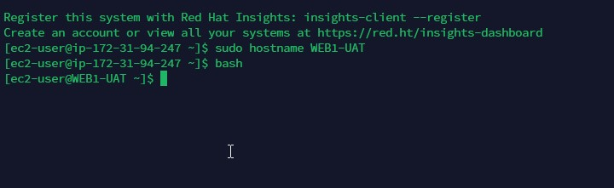

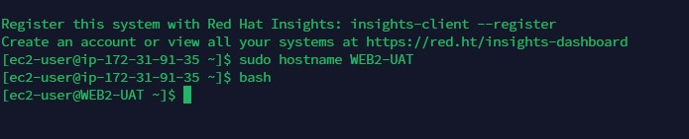

As you can see it is successful and we would be exiting out of them both as shown below

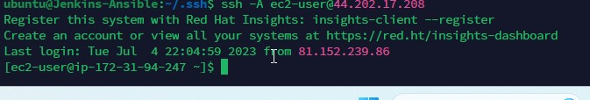

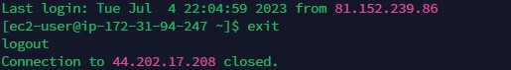

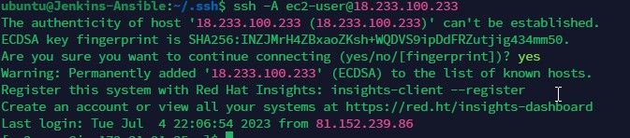

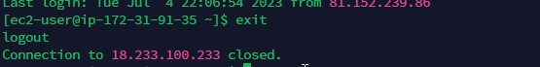

Once we successfully achieved this, we would navigate to the /etc/ansible/ansible.cfg file to uncomment roles path by providing the full path of our role directory as shown below.



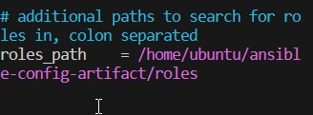

The next step would be to copy the yml file to the tasks folder with the code instructions on what to be carried out .There are 4 tasks we want to carry out in this single main.yml file .

1)Install APACHE HTTPD

2)Install git on each server Clone a tooling website from our GitHub

3) copy html content to the /var/www directory

4)Start our httpd service as shown below

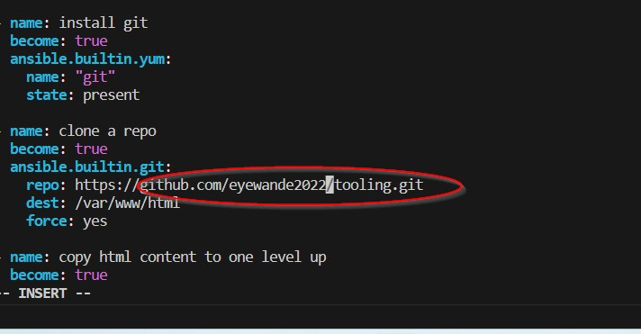

Our tasks file has been successfully updated 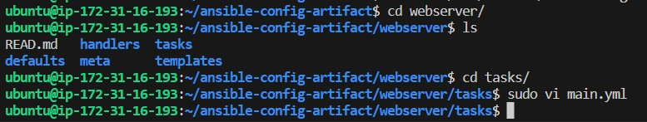

The next step would be to create a reference “Webserver Role”

**REFERENCE WEBSERVER ROLE**

Within the static-assignments folder, we create a uat-webservers.yml file and reference the roles as shown below on the terminal as well as on the Visual Studio terminal



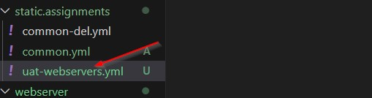

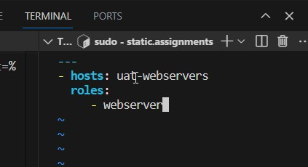

Since the entry point to our ansible configuration is the site.yml file .We would be referring our UAT webservers role inside the site.yml file as shown below

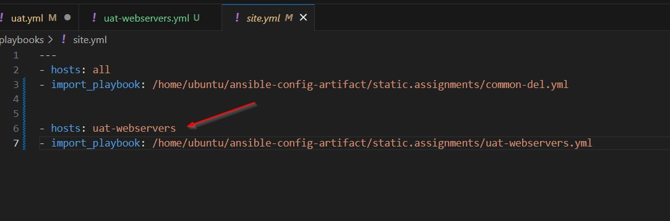

Once updated, we would be committing our changes

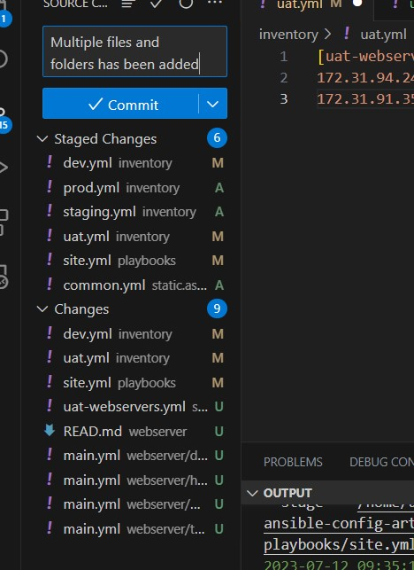

Open and create a pull request

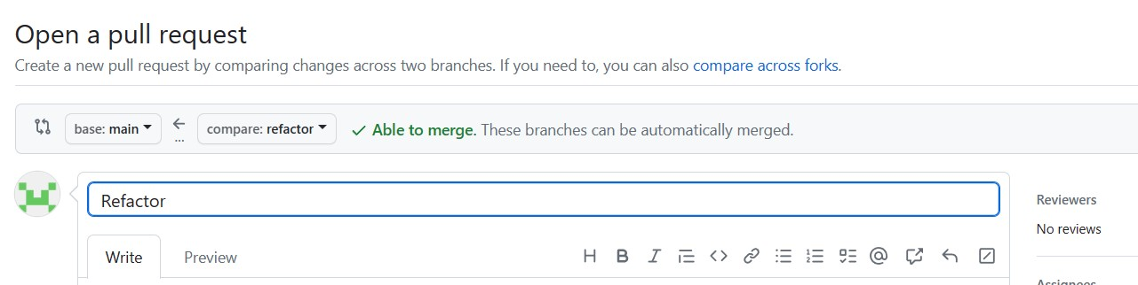

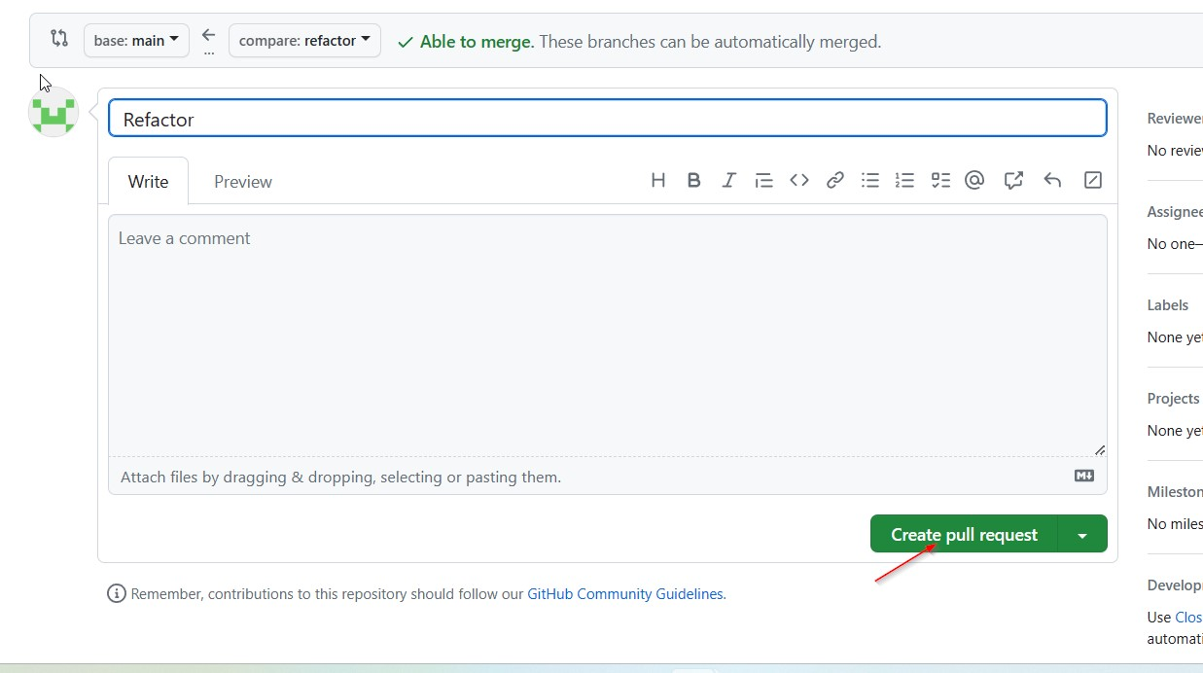

and merging to out (main branch).

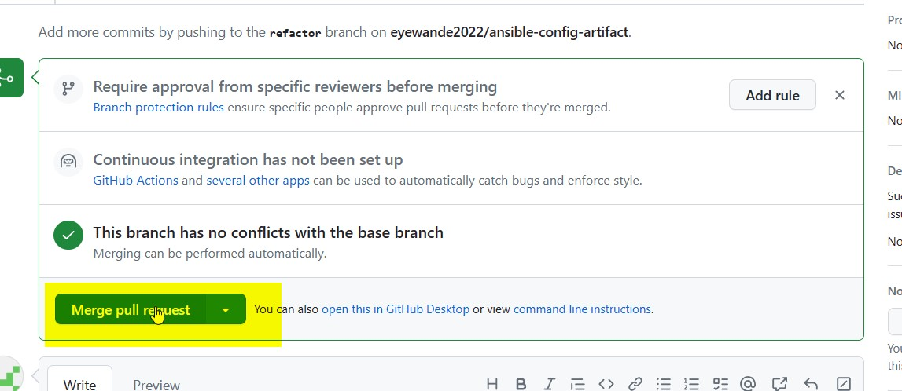

Successfully merged to main



Checking the main file, we can see all the files there

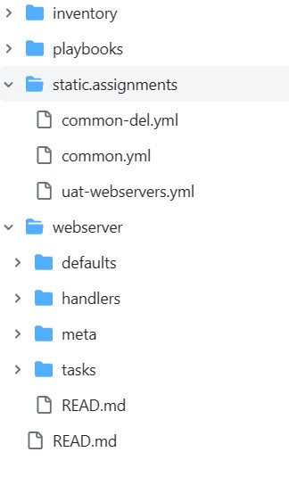

Once done we would be running out ansible playbook against our UAT inventory.

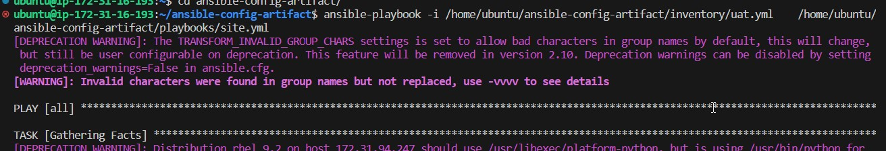

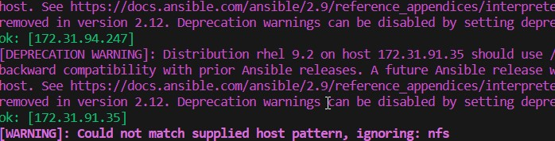

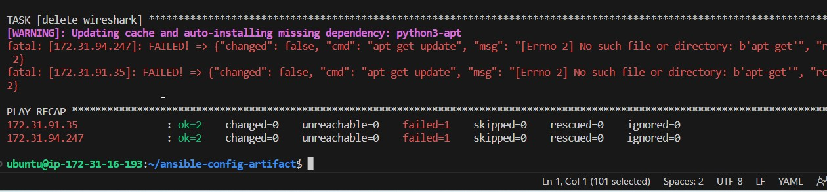

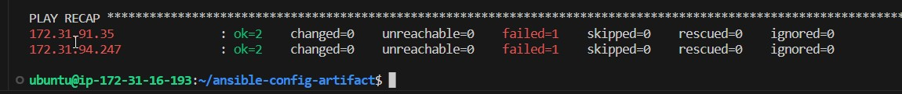

As shown above ,we can see that the 2 webservers , have been displayed and ran by the ansible playbook instructions and are well configured ..We can also notice some Ip address in red colour failing ,there were the other webservers that were turned off earlier having their own common-del.yml file (used to carry out the Wireshark deletion earlier )

Our full ansible architecture has now been refactored using our laptop with a functional internet and comprises of the list of components below.

1 Control Jenkins-ansible server

1 Database server

1 NFS server

1 Load balancer

2 UAT webserver

3 Webserver

We just deployed and configured a UAT Web Servers using import and roles .